Actividad 1 flutteer

Codigo:
import 'package:flutter/material.dart';

void main() {
runApp(const MyApp());
}

class MyApp extends StatelessWidget {
const MyApp({super.key});

@override
Widget build(BuildContext context) {
return MaterialApp(
title: 'Flutter Demo',
theme: ThemeData(
colorScheme: ColorScheme.fromSeed(seedColor: const Color.fromARGB(255, 37, 53, 199)),

),
home: const MyHomePage(title: 'Hola mundo'),
);
}
}

class MyHomePage extends StatefulWidget {
const MyHomePage({super.key, required this.title});

final String title;

@override
State<MyHomePage> createState() => _MyHomePageState();
}

class _MyHomePageState extends State<MyHomePage> {
int _counter = 0;

void _incrementCounter() {
setState(() {
_counter++;
});
}

void _decrementCounter() {
setState(() {
_counter--;
});
}

void _resetCounter() {
setState(() {
_counter = 0;
});
}

@override
Widget build(BuildContext context) {
return Scaffold(
appBar: AppBar(
backgroundColor: Theme.of(context).colorScheme.inversePrimary,
title: Text(widget.title),
),
body: Center(
child: Column(
mainAxisAlignment: MainAxisAlignment.center,
children: <Widget>[
const Text(
'You have pushed the button this many times:',
),
Text(
'$_counter',
style: Theme.of(context).textTheme.headlineMedium,
),
],
),
),
// Usamos Stack para colocar los botones en distintas posiciones
floatingActionButtonLocation: FloatingActionButtonLocation.centerFloat,
floatingActionButton: Stack(
children: [
// Botón restar (izquierda)
Align(
alignment: Alignment.bottomLeft,
child: Padding(
padding: const EdgeInsets.only(left: 30, bottom: 10),
child: FloatingActionButton(
onPressed: _decrementCounter,
tooltip: 'Restar',
child: const Icon(Icons.remove),
),
),
),
// Botón reiniciar (centro)
Align(
alignment: Alignment.bottomCenter,
child: Padding(
padding: const EdgeInsets.only(bottom: 10),
child: FloatingActionButton(
onPressed: _resetCounter,
backgroundColor: Colors.redAccent,
tooltip: 'Reiniciar',
child: const Icon(Icons.refresh),
),
),
),
// Botón sumar (derecha)
Align(
alignment: Alignment.bottomRight,
child: Padding(
padding: const EdgeInsets.only(right: 30, bottom: 10),
child: FloatingActionButton(
onPressed: _incrementCounter,
tooltip: 'Sumar',
child: const Icon(Icons.add),
),
),
),
],
),
);
}
}

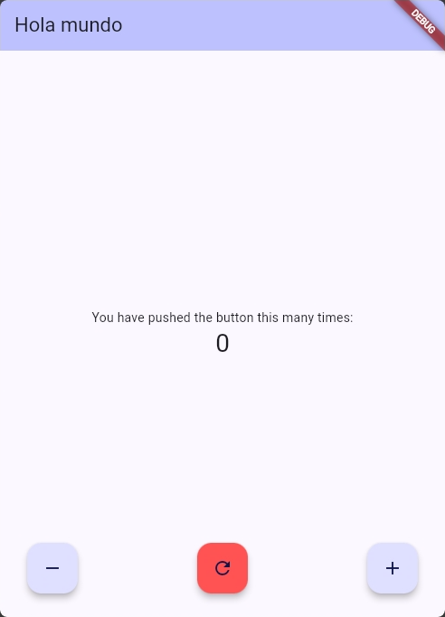
celular:

